**Steganography Image Hiding Tool**

**Technical Report**

**1. Project Overview**

This Python-based tool hides secret messages in images using **LSB steganography**, ensuring covert communication.

**2. Key Features**

* Hide/Extract Text in PNG/BMP images
* GUI Interface (Tkinter) with drag-and-drop support
* Error Handling for invalid inputs

**3. Technical Components**

Python Libraries:

python

from PIL import Image # Image processing

import stepic # LSB steganography

import tkinter as tk # GUI

**How It Works:**

1. Embedding:

- Converts text → binary → replaces LSBs of pixels

- Saves modified image (e.g., `secret_image.png`)

2. Extraction:

- Reads LSBs → reconstructs original message   
  
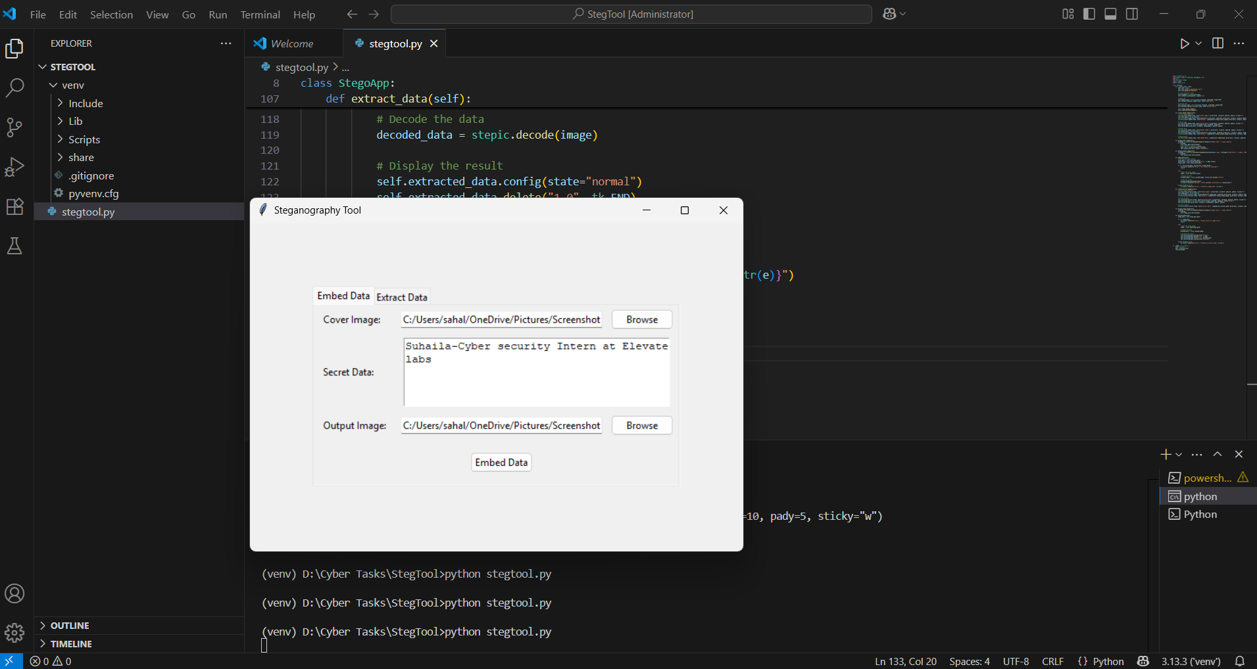 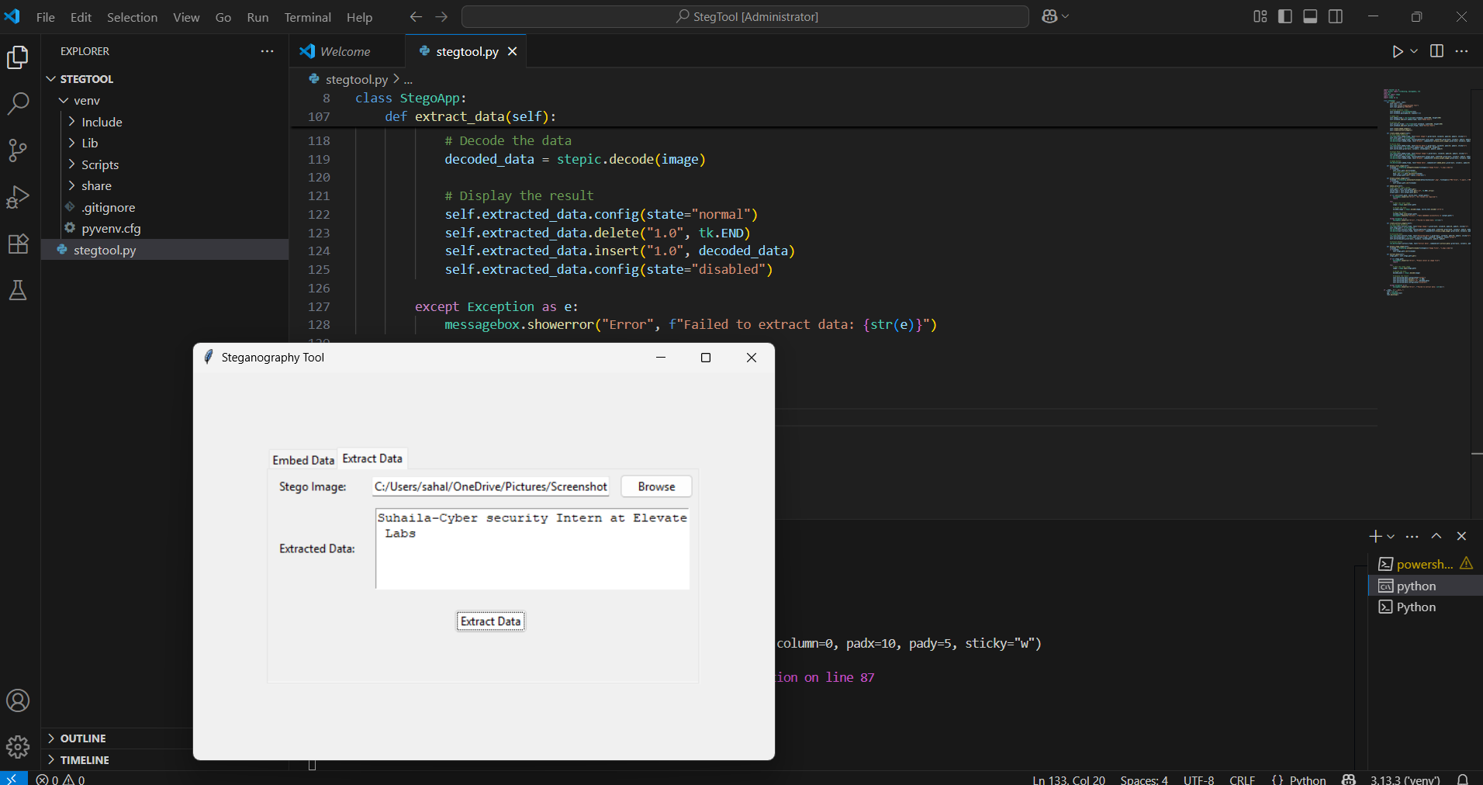  
  
Figure 1 & 2 : Embed an Extract window of Stegnography tool

**5. Usage Guide**

1. Embed Data:

- Load cover image → Enter text → Save stego-image

![](https://i.imgur.com/JQ1W0Yp.png)

2. Extract Data:

- Load stego-image → Click "Extract"

![](https://i.imgur.com/8vGXe3z.png)

**6. Limitations**

* Only supports lossless formats (PNG/BMP)
* No encryption (visible in code: `stepic.decode(image)` is plain)

**8. Conclusion**  
  
This tool demonstrates practical steganography for secure data hiding. For stronger security, combine with encryption.